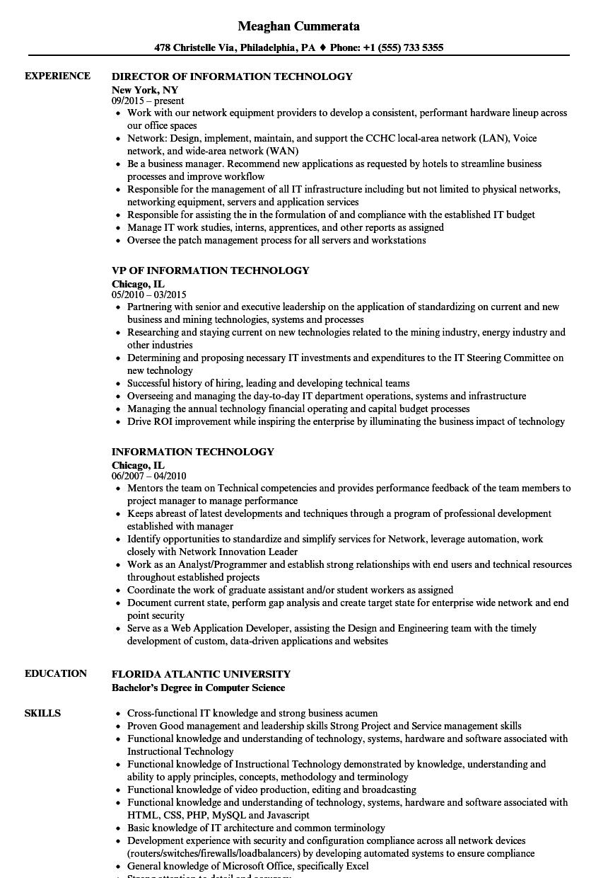
EXPERIENCE
Meaghan Cummerata
478 Christelle Via, Philadelphia, PA ♦ Phone: +1 (555) 733 5355
DIRECTOR OF INFORMATION TECHNOLOGY
New York, NY
09/2015-present
• Work with our network equipment providers to develop a consistent, performant hardware lineup across our office spaces
• Network: Design, implement, maintain, and support the CCHC local-area network (LAN), Voice network, and wide-area network (WAN)
• Be a business manager. Recommend new applications as requested by hotels to streamline business processes and improve workflow
• Responsible for the management of all IT infrastructure including but not limited to physical networks, networking equipment, servers and application services
• Responsible for assisting the in the formulation of and compliance with the established IT budget
• Manage IT work studies, interns, apprentices, and other reports as assigned
• Oversee the patch management process for all servers and workstations
VP OF INFORMATION TECHNOLOGY
Chicago, IL
05/2010-03/2015
⚫ Partnering with senior and executive leadership on the application of standardizing on current and new business and mining technologies, systems and processes
⚫ Researching and staying current on new technologies related to the mining industry, energy industry and other industries
⚫ Determining and proposing necessary IT investments and expenditures to the IT Steering Committee on new technology
• Successful history of hiring, leading and developing technical teams
• Overseeing and managing the day-to-day IT department operations, systems and infrastructure
• Managing the annual technology financial operating and capital budget processes
• Drive ROI improvement while inspiring the enterprise by illuminating the business impact of technology
INFORMATION TECHNOLOGY
Chicago, IL
06/2007-04/2010
• Mentors the team on Technical competencies and provides performance feedback of the team members to project manager to manage performance
• Keeps abreast of latest developments and techniques through a program of professional development established with manager
• Identify opportunities to standardize and simplify services for Network, leverage automation, work closely with Network Innovation Leader
• Work as an Analyst/Programmer and establish strong relationships with end users and technical resources throughout established projects
• Coordinate the work of graduate assistant and/or student workers as assigned
• Document current state, perform gap analysis and create target state for enterprise wide network and end point security
• Serve as a Web Application Developer, assisting the Design and Engineering team with the timely development of custom, data-driven applications and websites
EDUCATION
FLORIDA ATLANTIC UNIVERSITY
SKILLS
Bachelor's Degree in Computer Science
Cross-functional IT knowledge and strong business acumen
• Proven Good management and leadership skills Strong Project and Service management skills
• Functional knowledge and understanding of technology, systems, hardware and software associated with Instructional Technology
• Functional knowledge of Instructional Technology demonstrated by knowledge, understanding and ability to apply principles, concepts, methodology and terminology
• Functional knowledge of video production, editing and broadcasting
⚫ Functional knowledge and understanding of technology, systems, hardware and software associated with HTML, CSS, PHP, MySQL and Javascript
⚫ Basic knowledge of IT architecture and common terminology
• Development experience with security and configuration compliance across all network devices (routers/switches/firewalls/loadbalancers) by developing automated systems to ensure compliance
• General knowledge of Microsoft Office, specifically Excel

